Faculty Research
How Teacher Candidates Perceive GenAI Tools for STEM Lesson Planning
This white paper provides a summary of the work from:
Smith-Mutegi, D., Miles, M., Mohorn-Mintah, O. (In Press). The perception of GenAI tools in lesson planning: Implications for science teacher education. Contemporary Issues in Technology and Teacher Education.
Research Author Bios:
Dr. Demetrice Smith-Mutegi is an Assistant Professor of Science Education in the Department of Teaching and Learning. Dr. Monica Miles is an Assistant Professor of Engineering Education at the University at Buffalo. Dr. Olayinka Mohorn-Mintah is an Assistant Professor of Science Education at the University of Memphis.
White Paper Author:
Demetrice Smith-Mutegi
Overview
GenAI tools, such as ChatGPT and Microsoft’s CoPilot, are increasingly being recognized as potentially valuable resources for educators who are tasked with designing science lessons, developing rubrics, and creating assessments (Cooper, 2023). However, how these tools are perceived, employed, and integrated by STEM teachers, particularly those in the early stages of their careers, is still relatively unknown.
Purpose of the Research
This exploratory study examined how teacher candidates in a STEM methods course, the majority of whom were science teachers, engaged with generative artificial intelligence (GenAI) tools in lesson planning. This white paper focuses on two of the questions from the paper To what extent are GenAI tools being used in the creation of lesson plans, and what factors influence teachers’ decisions to use or not use these tools? andwhich GenAI tools are most used in lesson plan creation, and for what specific tasks or components are they considered most useful?
Method
This study employed an exploratory, descriptive research design to examine how teacher candidates enrolled in a STEM methods course in a Southeastern University integrated GenAI tools into their lesson planning, how they perceived the integration of these tools, and the factors influencing their adoption and use of these tools. During the course, the instructor selected and demonstrated GenAI tools to support 5E lesson planning including ChatGPT, Perplexity, MagicSchoolAI, etc., to promote the development of TPACK, and encourage reflective use of GenAI in lesson design. Considering the recent release of ChatGPT during the timeframe of this course, activities included the guided exploration of GenAI tools, citation of AI tools in lesson planning tasks, and structured reflection on the effectiveness and usability of these tools. It’s worth noting that GenAI tools were introduced as an additional layer of instructional support rather than a course requirement. Nine teacher candidates were enrolled in this course and participated in the data collection at each pertinent stage. Seven were teacher candidates with a secondary science focus and two had a secondary mathematics focus.
The instructor gathered data throughout the course using various quantitative and qualitative tools. These included a Pre/Post AI Perceptions and Experience Questionnaire, evaluating participants’ familiarity with GenAI tools, their perceptions of usefulness and ease of use, and their confidence in integrating AI into lesson planning; and an AI Tool Utilization Questionnaire, administered three times after each lesson plan submission to track which GenAI tools were used, for what specific tasks, and to gather short reflections on the benefits and challenges experienced with each tool.
Findings and Discussion
To answer RQ #1, the course instructor administered the short TPACK instrument. Descriptive analysis of the data showed participants improving their pedagogical and technological-pedagogical-content knowledge. The largest gain was seen in candidates’ perceptions of their ability to select effective teaching approaches to guide students' thinking in their content area. This indicates that even limited, structured exposure to GenAI tools can boost STEM teacher candidates’ confidence and skills in designing effective instruction. A figure illustrating the pre- and post-gains on select TPACK items (See Figure 1).
Figure 1
Select Pre-Post TPACK Survey Item Results
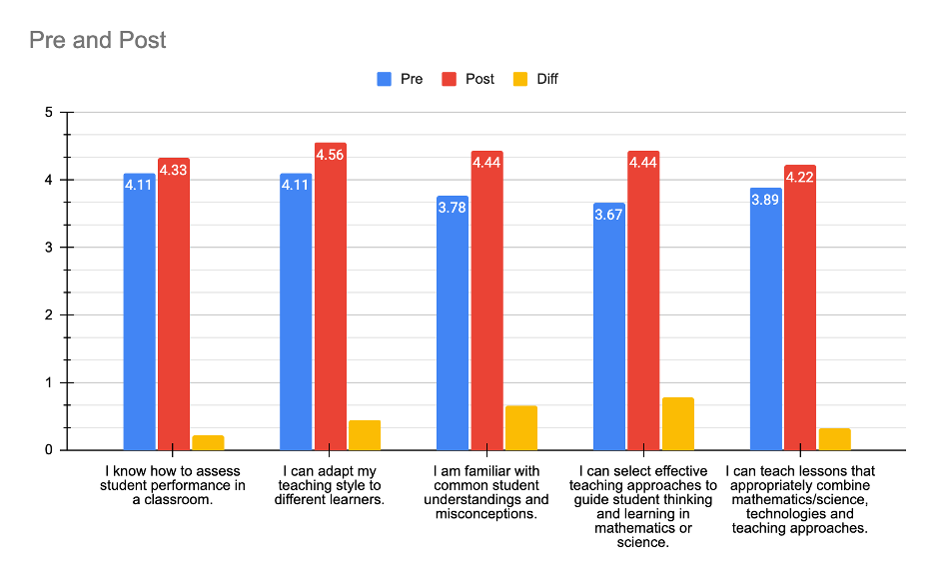
Note: From Smith-Mutegi et al., in press.

To answer RQ #2 and #3, participants completed the AI perceptions and experience survey at the beginning and end of the course and the AI tool utilization questionnaire after each lesson plan submission. Throughout the semester, the utilization of GenAI tools demonstrated an evolving pattern. At the start of the course, participants exhibited a cautious approach to GenAI. The majority of teacher candidates reported infrequent or nonexistent use of GenAI tools for lesson planning endeavors, whereas 33% indicated they employed GenAI tools on a weekly basis or less. One participant noted on the pre-survey, “I am anti AI but interested in hearing the benefits,” highlighting their reluctance to integrate AI into their practice but also remaining open to using it. Another participant noted after using ChatGPT, “It got me thinking and unstuck. Nothing like seeing ideas you don't like to get you working on ideas you do!” The tools cited by those who utilized GenAI technology included Grammarly, Khan Academy, Quizlet, and Desmos, which were predominantly employed for grammatical correction, paraphrasing, and content reinforcement. These choices exemplify a preference for familiar and low-risk AI applications, primarily used to support rather than control instructional design. By the end of the semester, more than 55% of the participants indicated that they frequently used GenAI and 11% (1 person) indicated that they never used it. This increase suggests going beyond introducing the GenAI tools, but instructors should provide scaffolded exposure to GenAI tools within classrooms, and in particular, teacher preparation classrooms, potentially leading to meaningful adoption of GenAI by future teachers.
Conclusions
Initially, participants used familiar tools cautiously for grammar correction and content reinforcement. By the end, they employed more advanced platforms for creating assessments, developing rubrics, and designing lessons. Nonetheless, some teachers chose not to incorporate GenAI into their lesson planning, citing reliance on district materials and mentor resources, as well as concerns about AI content accuracy and ethics. These barriers underscore the importance of trust and contextual relevance in technology adoption. Even among experimenters, some paused to consider whether the tools matched their instructional goals and values, highlighting the need for thoughtful, rather than automatic, integration.
The course’s focus on guided exploration and practice promoted meaningful engagement and supported TAM’s claim that professional development, even through coursework, positively impacts technology adoption (Guggemos & Seufert, 2021). The decision to adopt GenAI was nuanced, involving discernment between innovation and caution. As educational institutions introduce AI, they should foster environments that support thoughtful adoption, empowering teachers to explore, question, and selectively use tools aligned with their practice. To strengthen the generalizability of these findings, future research should include larger and more diverse samples across educational levels, disciplines, and geographic regions.
References
Cooper, G. (2023). Examining science education in ChatGPT: An exploratory study of generative artificial
intelligence. Journal of Science Education and Technology, 32, 444-452. https://doi.org/10.1007/s10956-023-10039-y.
Guggemos, J., & Seufert, S. (2021). Teaching with and teaching about technology–Evidence for
professional development of in-service teachers. Computers in Human Behavior, 115, 106613.
Schmid, M., Brianza, E., & Petko, D. (2020). Developing a short assessment instrument for
Technological Pedagogical Content Knowledge (TPACK.xs) and comparing the factor
structure of an integrative and a transformative model. Computers & Education, 157, 103967. https://doi.org/10.1016/j.compedu.2020.103967.

