Research from the Office of RIDIL
The Use of Extended Reality (XR) in Higher Education: A Systematic Review

This white paper provides a summary of the work from:
Burke, D., Crompton, H., & Nickel, C. (2025). The Use of Extended Reality (XR) in Higher Education: A Systematic Review. TechTrends. https://doi.org/10.1007/s11528-025-01092-y
Research Author Bios:
Dr. Helen Crompton is a Professor of Instructional Technology in the Department of STEM and Professional Studies, and the Executive Director of the Research Institute for Digital Innovation in Learning at ODUGlobal at ODU. Dr. Diane Burke is a Senior Research Associate at the Research Institute for Digital Innovation in Learning at ODUGlobal at ODU. Dr. Christine Nickel is a Senior Instructional Designer for the Division of Digital Transformation & Technology at ODUGlobal.
Overview
Extended Reality (XR) includes the use of Virtual Reality (VR), Augmented Reality (AR), and Mixed Reality (MR). The use of this technology in higher education (HE) has grown significantly as advancements in technology and the resulting ability to enhance learning experiences has gained increasing recognition.
Purpose of Research
The purpose of this research is to conduct a systematic review of existing literature to analyze higher education research on the use of extended reality (XR) between 2020 and 2024. The overarching question for the study is what are the trends in HE research regarding the use of XR? Sub questions provide information about geographic locations of the research, types of XR used, educational levels and disciplines involved, how XR is used for learning and what are the challenges when using XR?
Method
A PRISMA systematic review methodology was used to determine the articles that would be included in this systematic review. Then, apriori and grounded coding revealed the trends in answering these research questions.
Findings and Discussion
This study provides unique findings with an up-to-date examination of the use of XR in HE from 2020-2024. It is the first systematic review that looks at all types of XR across multiple dimensions. The findings revealed that research on XR took place across the globe in 48 different countries and on six continents. The fact that the study of XR is happening globally indicates significant interest in the use and potential of this technology.

Geographic location of studies

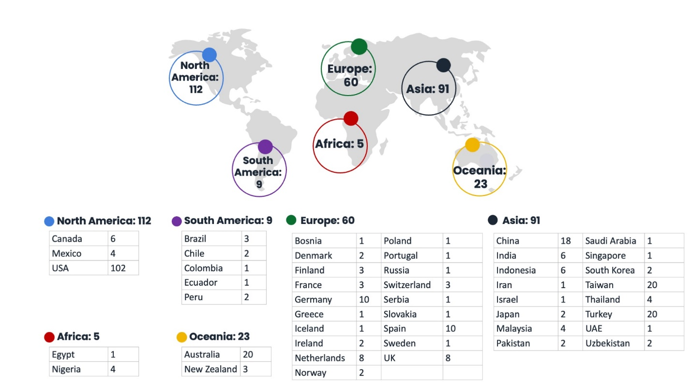

Types of XR used
The data showed that VR was the most frequently used type of XR in the research studies (58%), followed by AR (33%), MR (7%) and finally XR (2%). Virtual Reality (VR) may have more studies focused on this type of reality because the VR environment is easier to control than other types of XR.
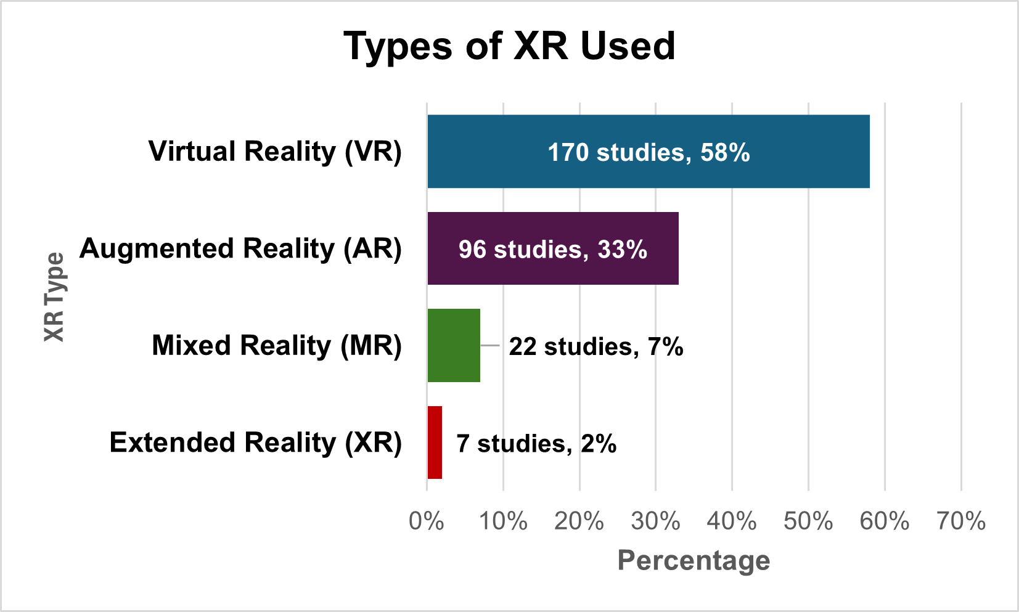

Educational Levels
The findings revealed that the majority of the studies took place at the undergraduate level (81%). Studies at the graduate level took place in 15 % of the studies and 3% of the studies involved undergraduate and graduate students. Only 1% of the studies took place investigating XR with HE faculty. The results of this study may be due to the fact undergraduate students make up 80-90% of the total student population in HE institutions, while graduate students make up the remaining 10-20%.
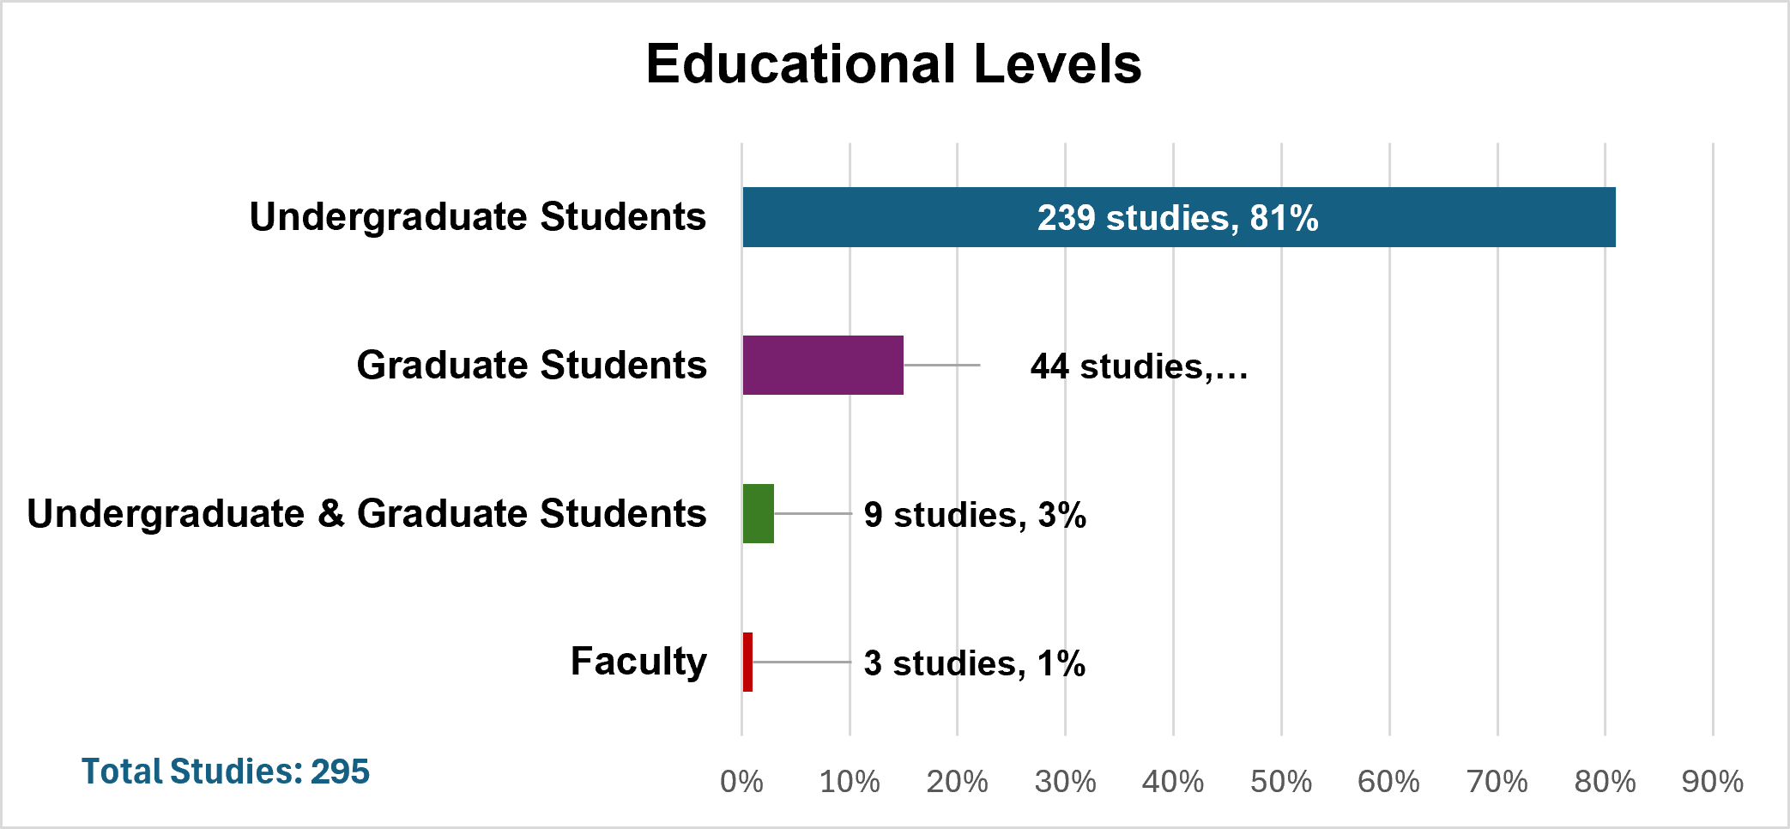

Academic Disciplines
The investigation of the academic disciplines involved in researching the use of XR revealed 10 academic disciplines. The academic discipline with the most studies was science (21%). Next was education (20%) and then engineering (14%). The remaining disciplines were medical studies (11%) second language study (8%), social science, humanities and arts (10%), business (4%), architecture (2%), math (1%), and other (7%). One of the benefits of XR is providing with students access to situations they would not normally have, giving them have the opportunity to practice skills and learn from their mistakes without real-world consequences. The top three disciplines in which XR research took place, science, teacher education, and engineering are disciplines in which students can benefit from simulations that create physical phenomena and environments that can provide real-life learning opportunities, in the laboratory, the classroom, or the field.
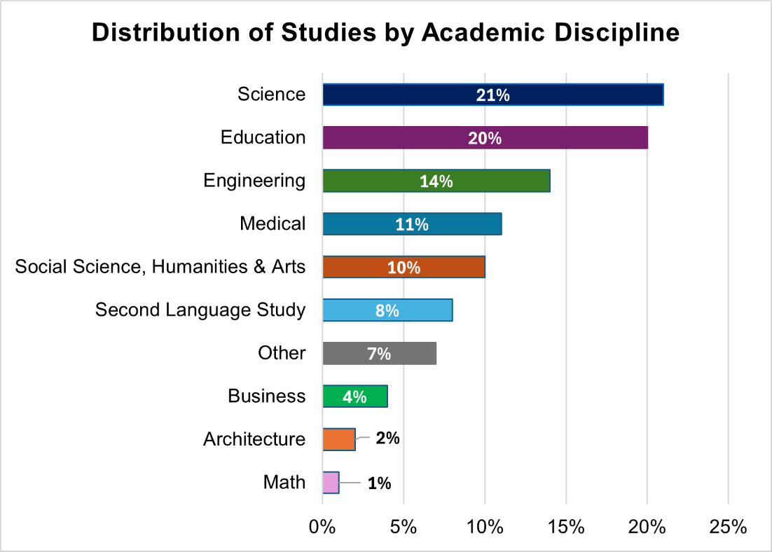

How XR was used for learning
The grounded coding of the data revealed three overarching domain codes for using XR to facilitate learning: the knowledge domain, the psychomotor domain, and the affective domain. These domains match existing established educational frameworks for different types of learning. In addition, the grounded coding of the data revealed that XR was being used in four different ways: 1) Simulation, 2) Visualization, 3) Problem-solving, and 4) Gaming. Each of these approaches provided different affordances for student learning.
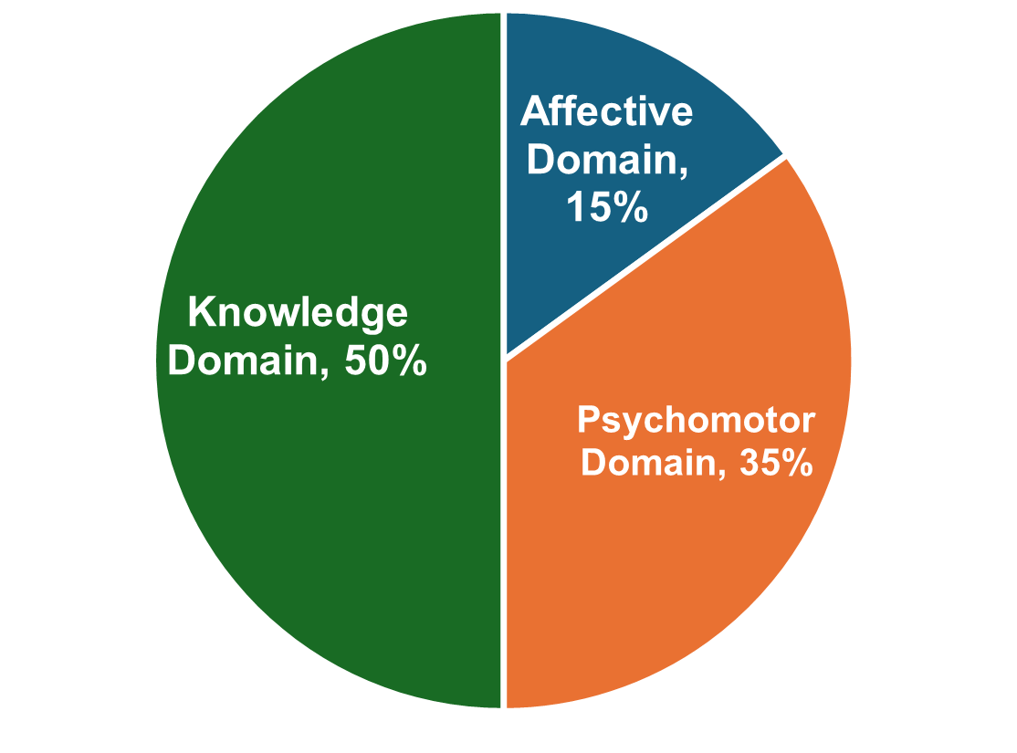
Domains of Use
Identified Challenges
Integrating XR into HE presents challenges. It is important to examine these challenges to ensure that the full potential of these technologies is effectively harnessed. From the data, grounded coding identified four codes for challenges with 14 axial codes. The four codes were 1) Impact on students, 2) Money and Time, 3) Inauthentic environments, and 4) Usability and technical issues. Each of the codes also had a number of axial codes to further identify the challenges presented by XR.

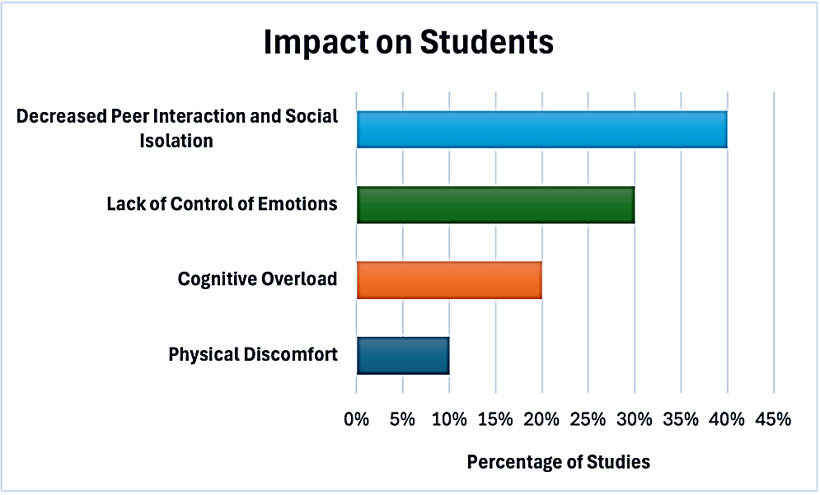
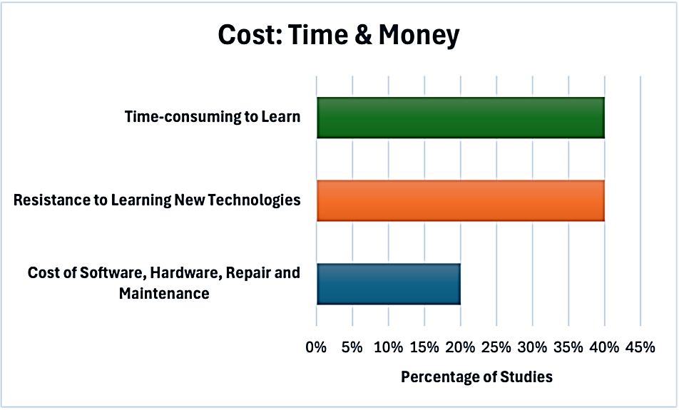
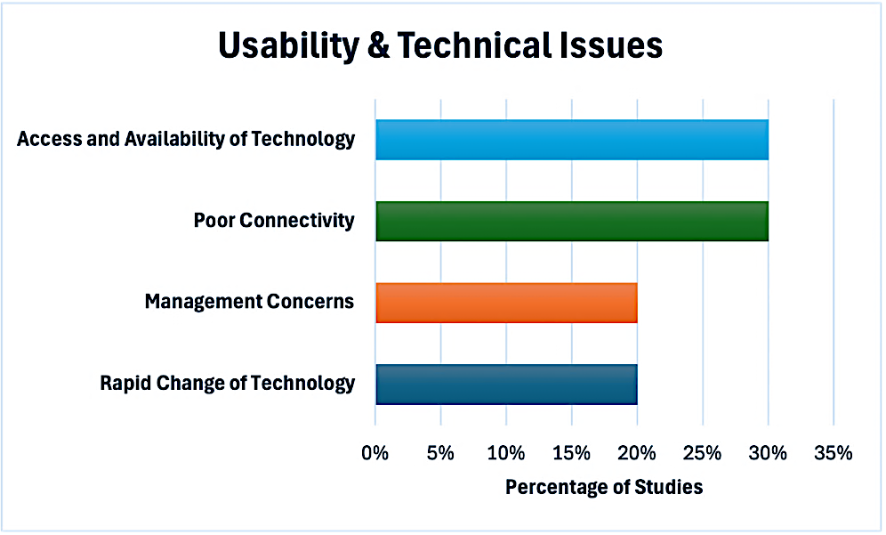
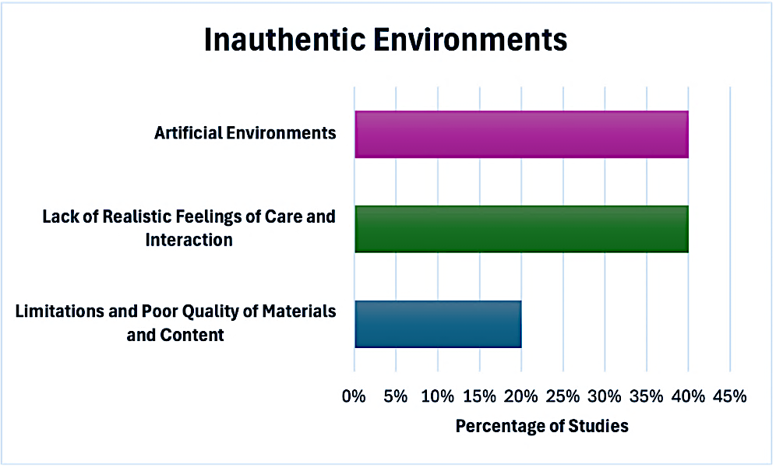
Conclusion
This study examined the use of XR in HE from 2020-2024. This white paper provides a brief snapshot of the research from the published manuscript, which answered the overarching question what are the trends in HE research regarding the use of XR? Sub questions provided information about geographic locations of the research, types of XR used, educational levels and disciplines involved, how XR was used for learning and challenges when using XR? Examples of these trends can be found in the main paper with further detailed descriptions of each of the five areas. Researchers, practitioners, policymakers, and funders can use these findings as a springboard to future studies on XR, with a clear direction as to the existing knowledge and the gaps that need to be addressed.

